Project Design Phase-II
Data Flow Diagrams & User Stories
Date | 30 September 2026
Team ID | AI Study Buddy API
Project Name | AI Study Buddy API
Maximum Marks | 4 Marks

Data Flow Diagrams:
A Data Flow Diagram (DFD) shows how information moves through the AI Study Buddy API. It represents how a student sends study questions or learning requests, how the API processes the request using the AI service and study data, and how the response, quiz, study plan, or progress information is returned to the student.
AI Study Buddy API – DFD Level 0 (Simplified)
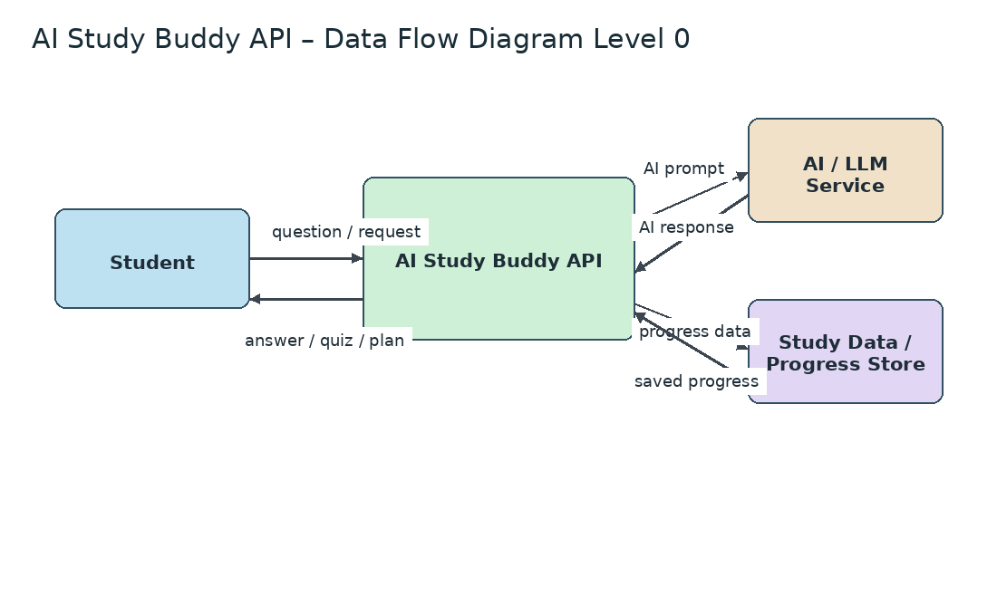

AI Study Buddy API – DFD Level 1
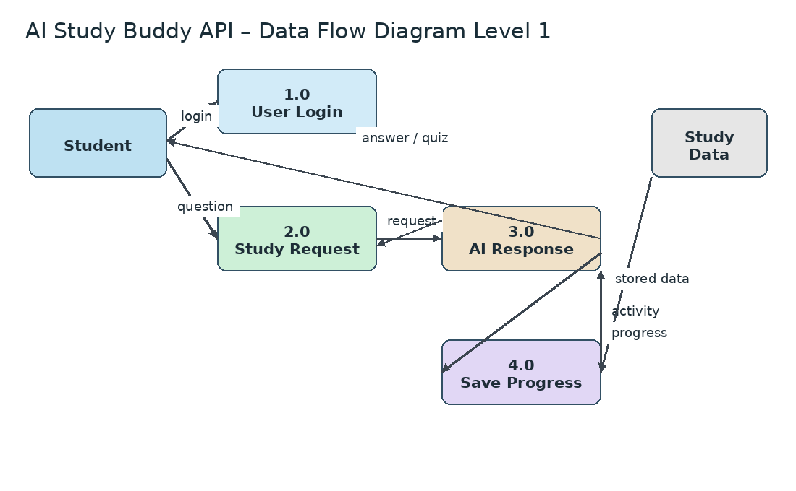
AI Study Buddy API – Student Learning Flow
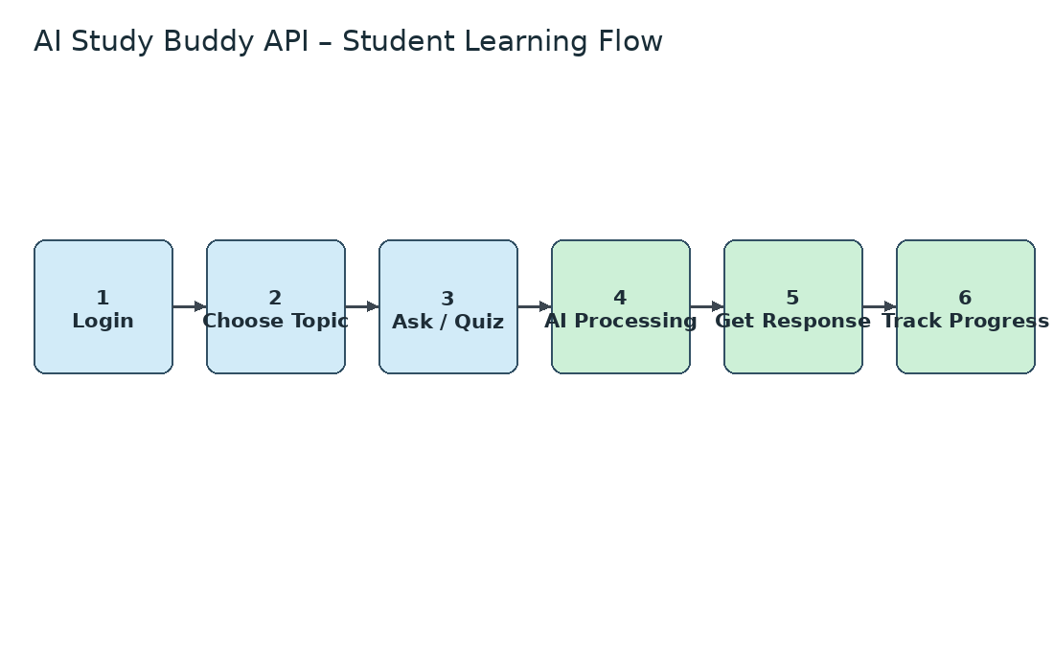

User Stories
Use the below template to list all the user stories for the AI Study Buddy API.
User Type | Functional Requirement  (Epic) | User Story  Number | User Story / Task | Acceptance criteria | Priority | Release
Student (Web user) | Registration & Login | USN-1 | As a student, I can register and log into the AI Study Buddy API using my basic account details. | I can securely access my study dashboard. | High | Sprint-1
 | Study Question | USN-2 | As a student, I can enter a study question and receive an AI-generated explanation. | The API returns a relevant and understandable answer. | High | Sprint-1
 | Personalized Learning | USN-3 | As a student, I can request explanations based on my learning level and topic. | The response is adapted to the selected topic and level. | High | Sprint-1
 | Quiz Generation | USN-4 | As a student, I can generate practice questions or quizzes for a selected subject. | A quiz is generated with questions and answers for practice. | High | Sprint-2
 | Study Plan | USN-5 | As a student, I can create a study plan based on my subjects and available study time. | The system provides a structured study schedule. | Medium | Sprint-2
 | Progress Tracking | USN-6 | As a student, I can view my quiz performance and learning progress. | The dashboard displays completed activities and progress. | Medium | Sprint-2
 | Language Support | USN-7 | As a student, I can select a preferred language for explanations. | The API provides the response in the selected language when supported. | Medium | Sprint-2
 | Learning Resources | USN-8 | As a student, I can request key points, summaries, and examples for a topic. | The system provides concise study content for revision. | Medium | Sprint-2
Student (Web user) | Dashboard | USN-9 | As a student, I can view my questions, quizzes, study plan, and progress from one dashboard. | All available learning features are accessible from the dashboard. | High | Sprint-2
AI Study Buddy API | API Processing | USN-10 | As the system, I can send a validated student request to the AI service and receive a response. | The API processes the request and returns a response without exposing sensitive data. | High | Sprint-1
Administrator | System Monitoring | USN-11 | As an administrator, I can monitor API usage and basic system activity. | The administrator can view usage and system status information. | Low | Sprint-3

